Report:

Based on the analysis of events, We have found that:

* New package rolls in a packaging machinery and max speed on the production line often leads to production machinery being down for over 5 minutes
* Production machinery being down for over 5 minutes and max speed on the production line leads to New package rolls being in a packaging machinery
* Max speed on the production line often leads to production machinery being down for over 5 minutes and new package rolls being in a packaging machinery
* Production machinery being down for over 5 minutes and New package rolls being in a packaging machinery often leads to max speed on the production line

What causes the production problems and how to fix them:

* The downtime in production is often caused by your need to replace packaging rolls
* Your need to replace packaging rolls is caused by running your production line at max speed
* To fix your machinery downtime, try running your production line at 80% to 90% of its max speed to slow the need for replacing packaging rolls and develop a faster way to replace packaging rolls to reduce downtime each time it needs to be replaced

Written Steps:

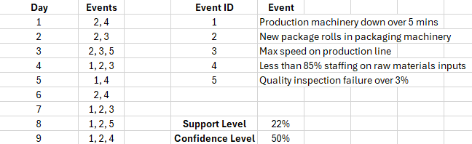

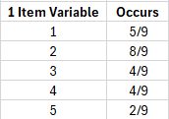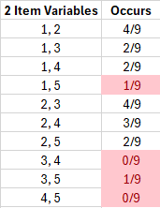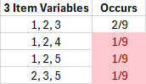

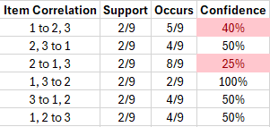

R Studio Steps:

